|  |  |
| --- | --- |
| *НАСЕКОМЫЕ В КАРТИНКАХ* |  |

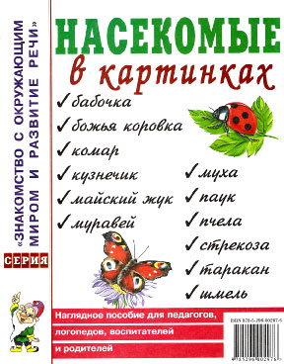

[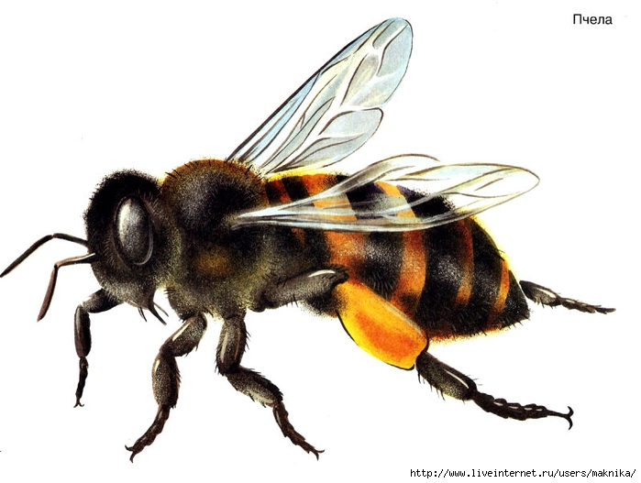](http://img1.liveinternet.ru/images/attach/c/9/106/767/106767871_large_n2.jpg)  
  
  
[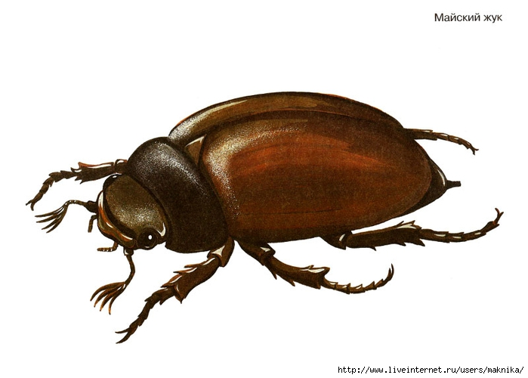](http://img0.liveinternet.ru/images/attach/c/9/106/767/106767874_large_n3.jpg)  
  
  
[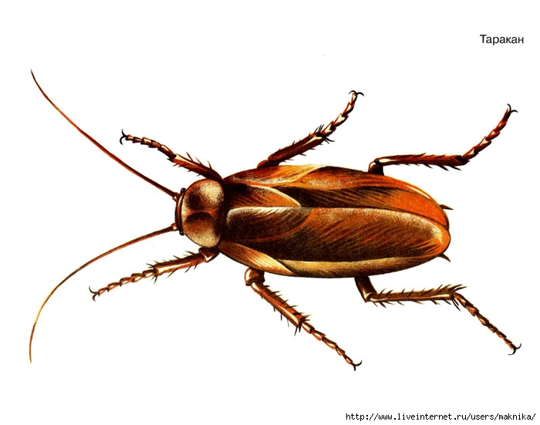](http://img1.liveinternet.ru/images/attach/c/9/106/767/106767877_large_n5.jpg)  
  
  
[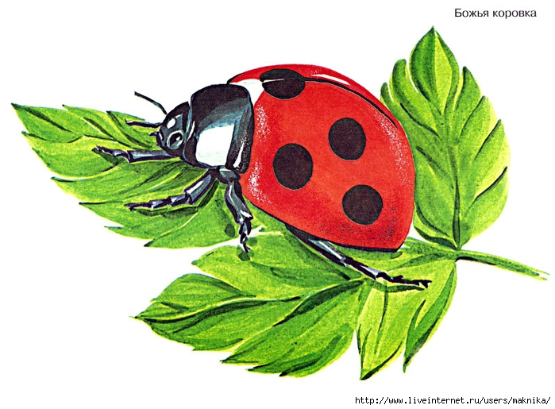](http://img0.liveinternet.ru/images/attach/c/9/106/767/106767878_large_n6.jpg)  
  
  
[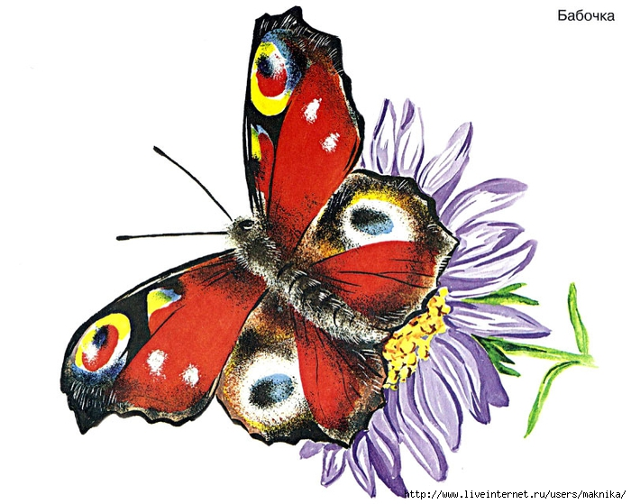](http://img0.liveinternet.ru/images/attach/c/9/106/767/106767880_large_n7.jpg)  
  
  
[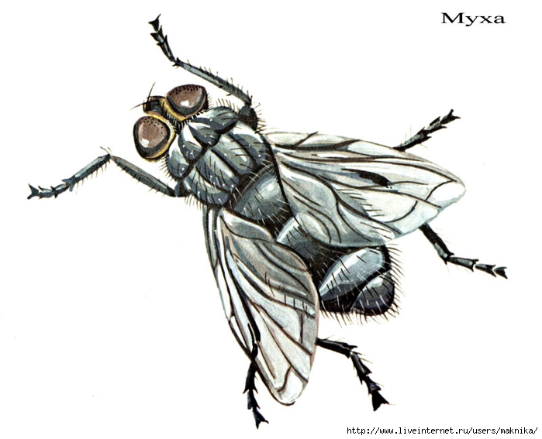](http://img0.liveinternet.ru/images/attach/c/9/106/767/106767884_large_n8.jpg)  
  
  
[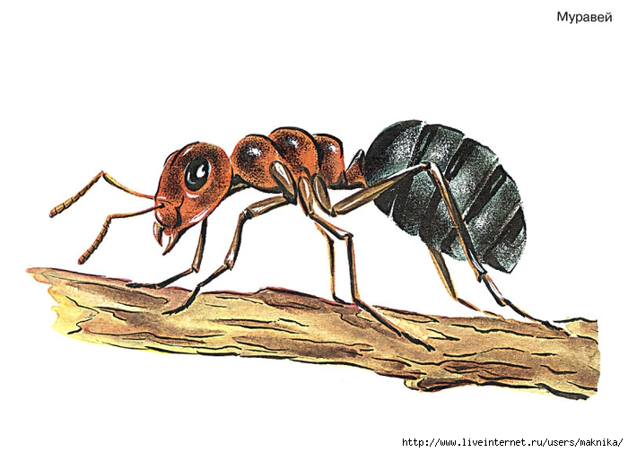](http://img0.liveinternet.ru/images/attach/c/9/106/767/106767886_large_n9.jpg)  
  
  
[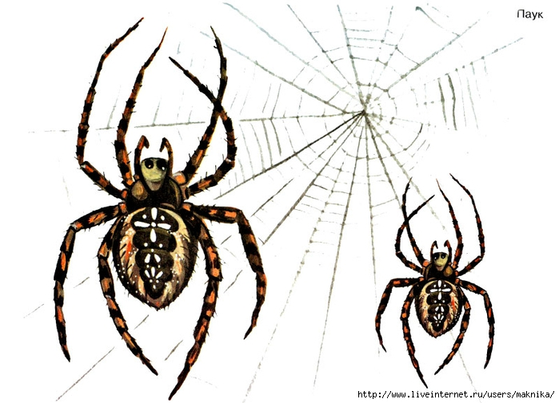](http://img0.liveinternet.ru/images/attach/c/9/106/767/106767888_large_n10.jpg)  
  
  
[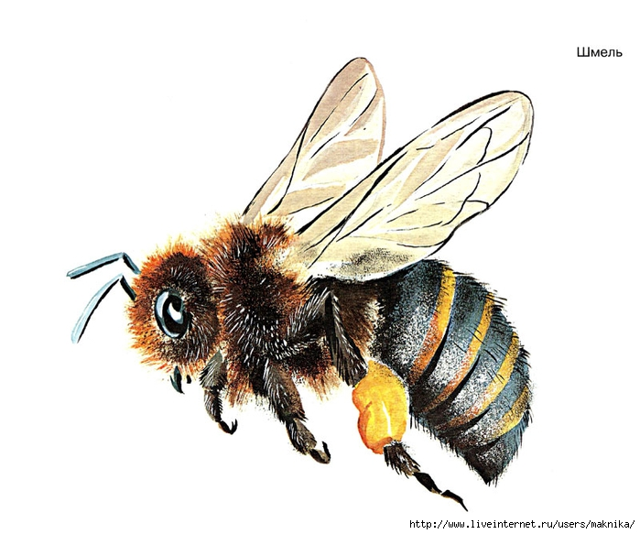](http://img0.liveinternet.ru/images/attach/c/9/106/767/106767890_large_n11.jpg)  
  
  
[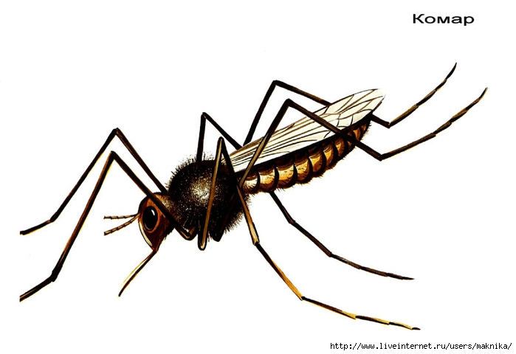](http://img0.liveinternet.ru/images/attach/c/9/106/767/106767892_large_n12.jpg)  
  
  
[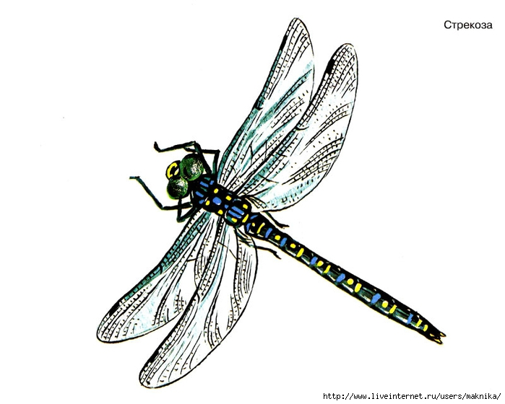](http://img0.liveinternet.ru/images/attach/c/9/106/767/106767894_large_n13.jpg)  
  
  
[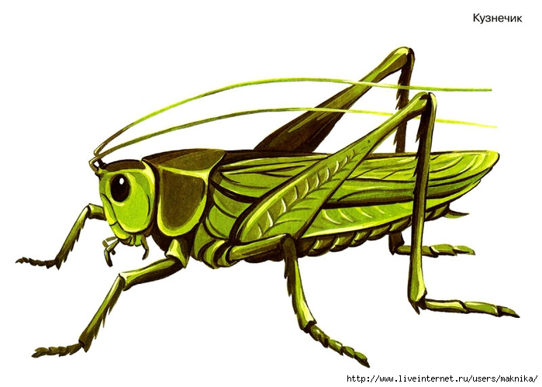](http://img1.liveinternet.ru/images/attach/c/9/106/767/106767895_large_n14.jpg)  
  
  
[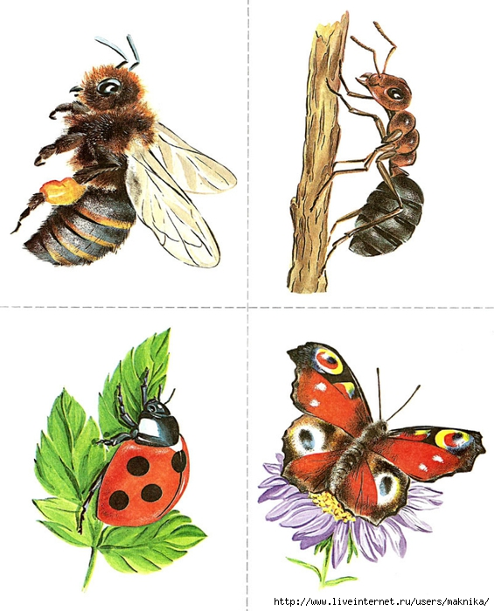](http://img1.liveinternet.ru/images/attach/c/9/106/767/106767897_large_n15.jpg)  
  
  
[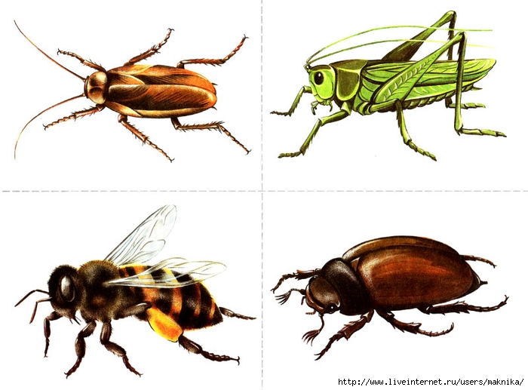](http://img0.liveinternet.ru/images/attach/c/9/106/767/106767900_large_n16.jpg)  
  
  
[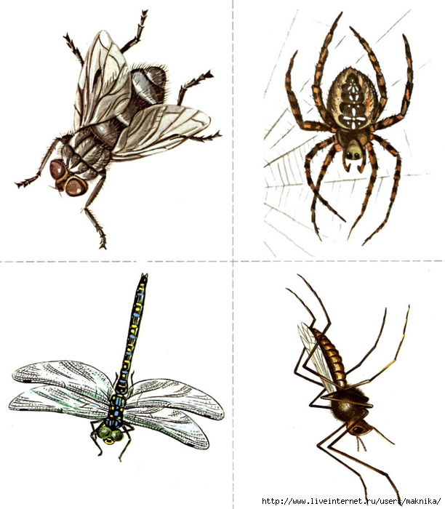](http://img0.liveinternet.ru/images/attach/c/9/106/767/106767902_large_n17.jpg)